|  |
| --- |
| *CometPark* |
| **System Architecture Document** |
| **SE 6387 Advanced Software Engineering Project**  **R.Z. Wenkstern**    ***06/03/2014*** |

|  |
| --- |
| **Group B *002*** |
| Arunkumar Manickam |
| Hariprasad Natarajan |
| Prasanna Venkatesh Venkitasamy |
| Rekha Muthulakshmi Nachadalingam |

# 

# Revision History

|  |  |  |  |
| --- | --- | --- | --- |
| **Version** | **Date** | **Decription** | **Authors** |
| 1.0 | 03/06/2014 | Completed initial draft | Arunkumar, Hariprasad Prasanna, Rekha |

Contents

Revision History 2

List of Figures 1

1. Subsystems Sequence Diagrams 2

1.1 Update Parking Spot Status 2

1.2 Find Vacant Parking Spot 3

1.3 Login 4

1.4 Manage Parking Spot 5

1.5 Update System Configuration 6

2. System Architecture with Operations 7

Appendix B: References 8

# List of Figures

Figure 1 Update Parking Spot Status 2

Figure 2 Find Vacant Parking Spot 3

Figure 3 Login 4

Figure 4 Manage Parking Spots 5

Figure 5 Update System Configuration 6

Figure 6 System Architecture 7

# 1. Subsystems Sequence Diagrams

## 1.1 Update Parking Spot Status

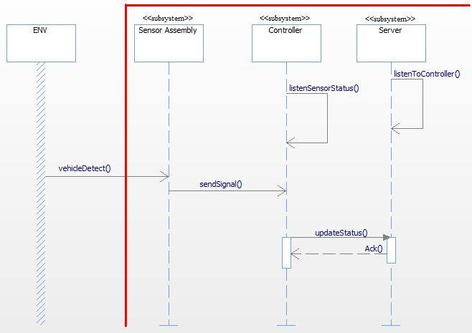

Figure Update Parking Spot Status

## 1.2 Find Vacant Parking Spot

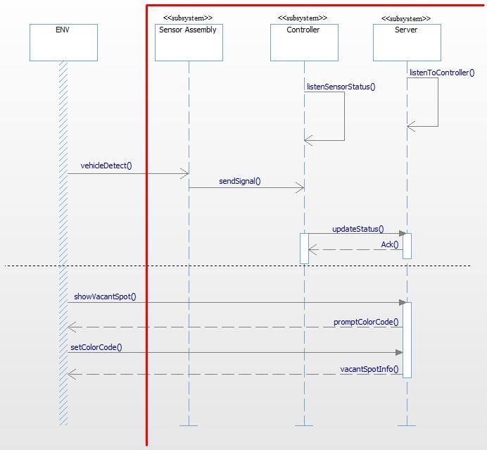

Figure Find Vacant Parking Spot

## 1.3 Login

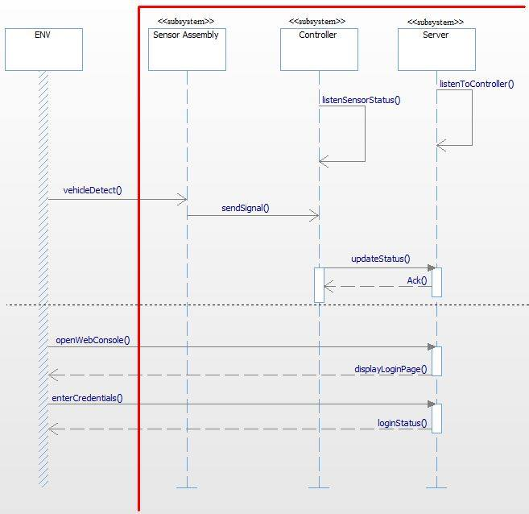

Figure Login

## 1.4 Manage Parking Spot

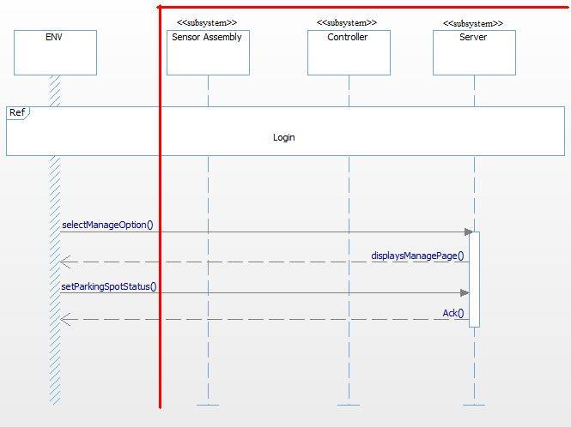

Figure Manage Parking Spots

## 1.5 Update System Configuration

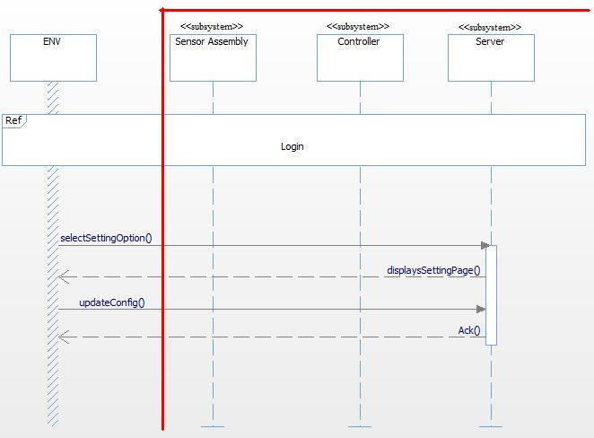

Figure Update System Configuration

# 2. System Architecture with Operations

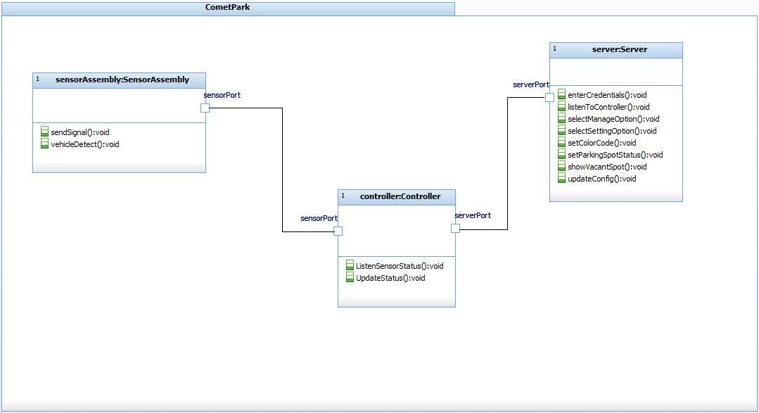

Figure 6 System Architecture

# Appendix B: References

1. IBM Rational Rhapsody Tutorial <http://publib.boulder.ibm.com/infocenter/rsdp/v1r0m0/topic/com.ibm.help.download.rhapsody.doc/pdf75/tutorialcpp.pdf>